// Home page.html //

<html>

<title>web page</title>

<H1> Home page</H1>

<a href ="1.html"> <li> data of html </li> </a>

<li> anchor data of html </li

</html>

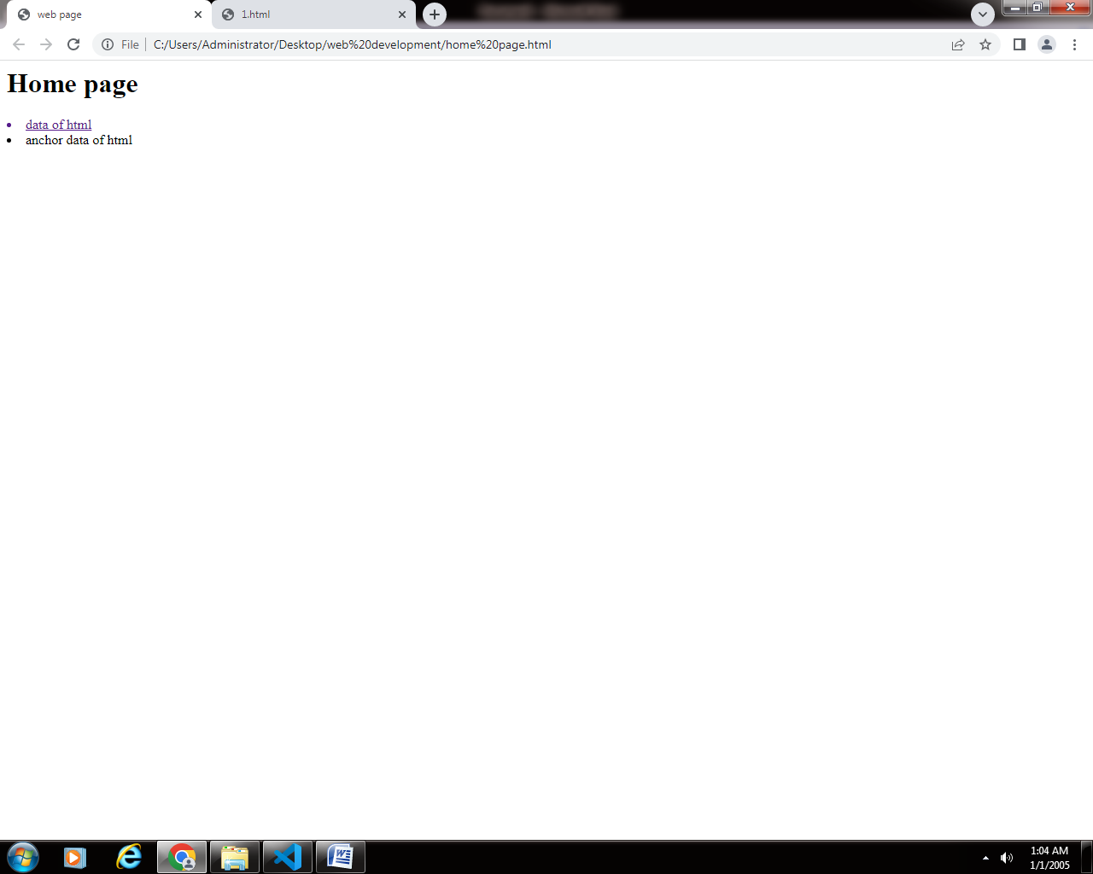

// para 1.html //

<html>

<body bgcolor="black">

<p style="color: white" > hfvfbxvjsjkfsnzsjvdnjkxnvsdlnedklcnsdldnsdklnsdksdnsdklnxklsdklmdvv </p>

<a href ="Home.html"> Back </a>

</body>

</html>

